CCA of WA Scholarships
How to get your schedule and tuition documentation in ctcLink

Enrollment Information
- From the ctcLink Student Homepage, select “Manage Classes”
- Select the academic quarter
- Click the “Printable Page” button
- A new window will appear showing your classes, full name, academic term, and your college’s name. Use the “Print” button to print to a PDF

Enrollment Information: Screen Shots

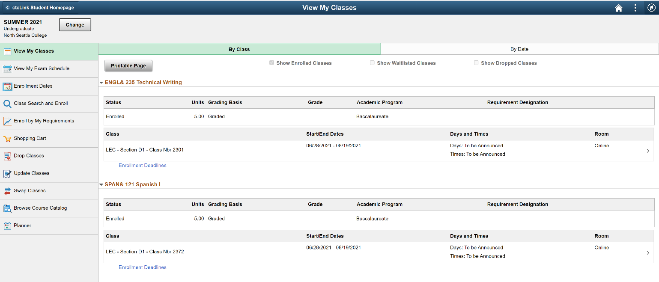

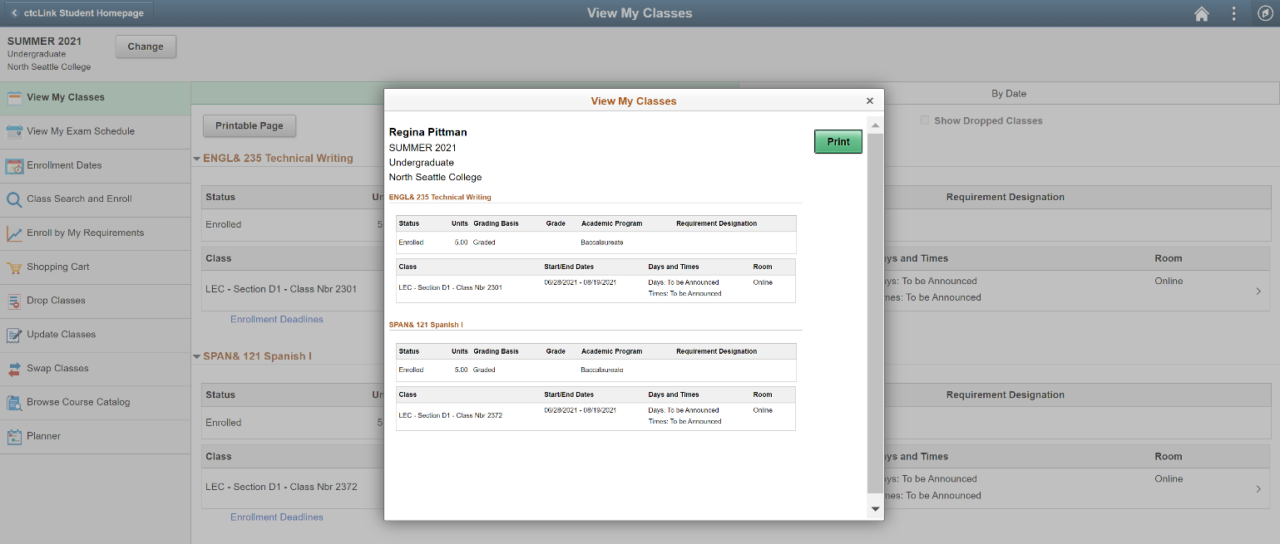

Tuition Information
- From the ctcLink Student Homepage, select “Financial Account”
- In the menu on the left-hand side of the page, select “Charges” and “Charges Due”
- Switch the view to “Detail of Charges Due”
- Take a screen shot of the page to save all information. Printing the webpage to a PDF tends to cut off the right-hand side of the page. Use the Print Screen (PrtScr) button on your keyboard, the Snipping Tool (Windows), Grab (Mac) or take a photo of the screen.

Tuition Information: Screen Shots

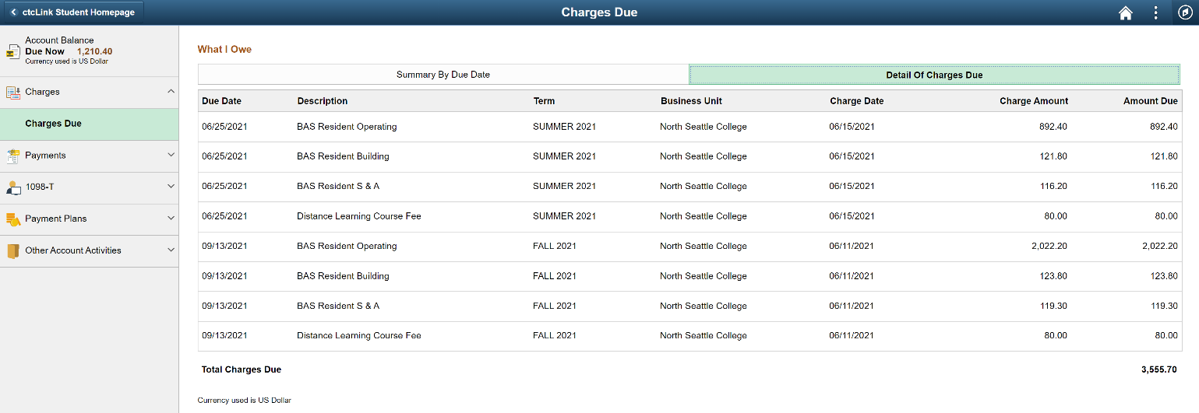

Send all schedule information to scholarships@childcareawarewa.org
Once we have received your enrollment and tuition information, we will email you if any additional information or documentation is required. You will receive a copy of the tuition voucher email that is sent to your college.

